**LIT TRAINING**

**Batch Name - SAP ABAP - 25                                                            DAY 11 ASSIGNMENT**

**EMPLOYEE ID – 46247689**

**CEATION OF SMARTFORMS**

**UPLOAD LOGO THROUGH SE78**

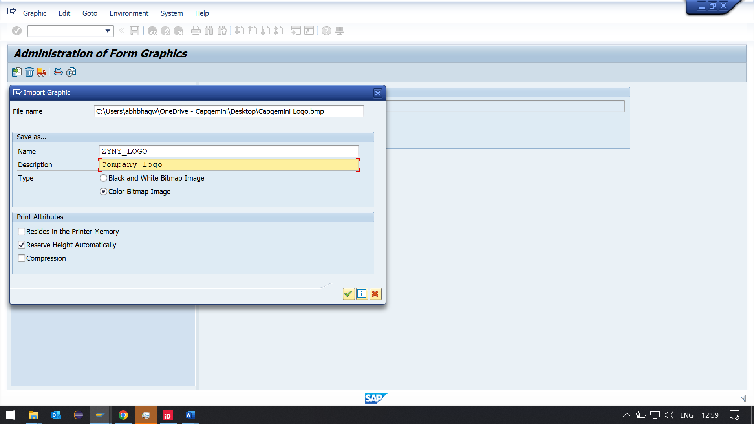

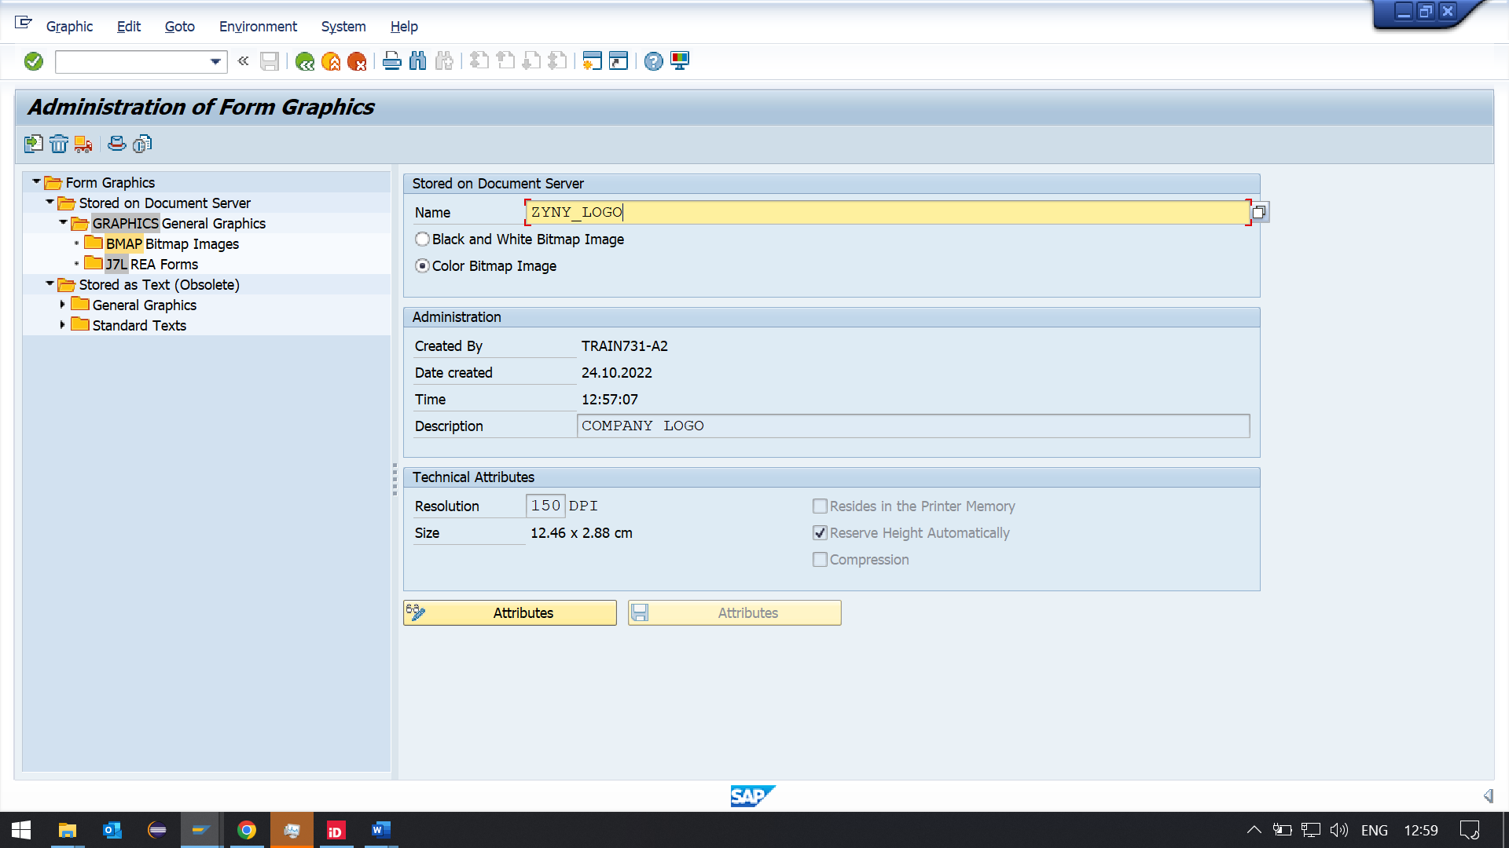

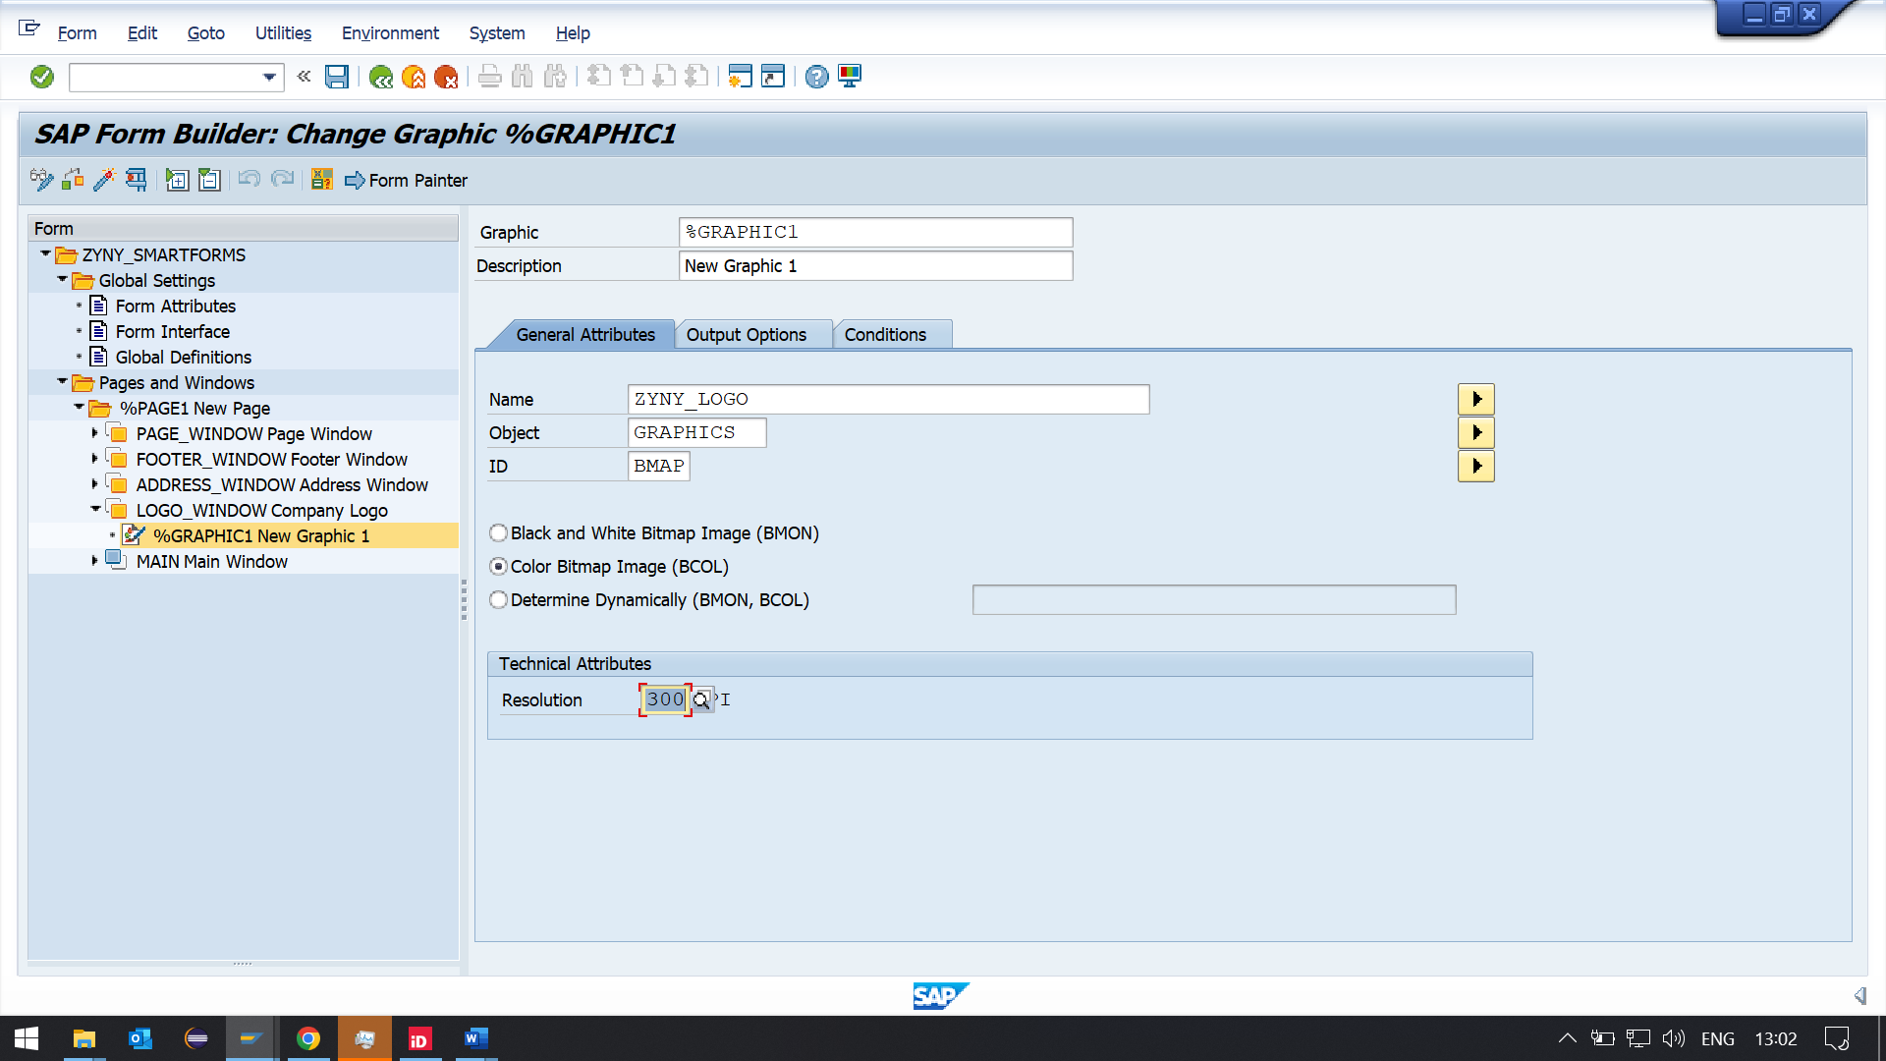

**TEXT ELEMENT FOR LOGO TO DISPLAY DATE**

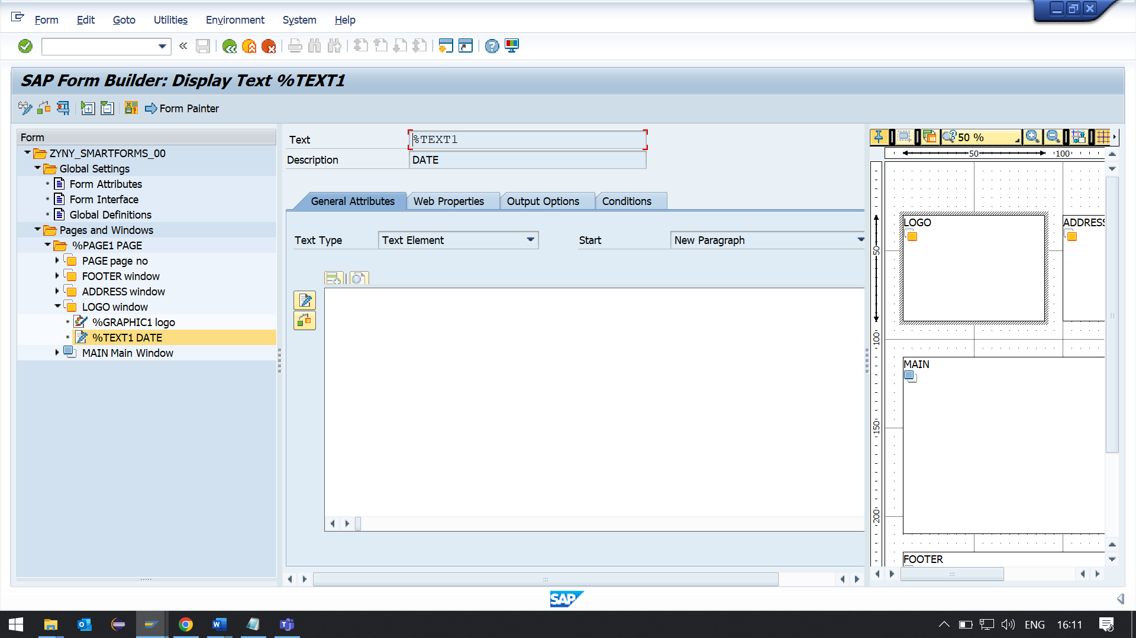

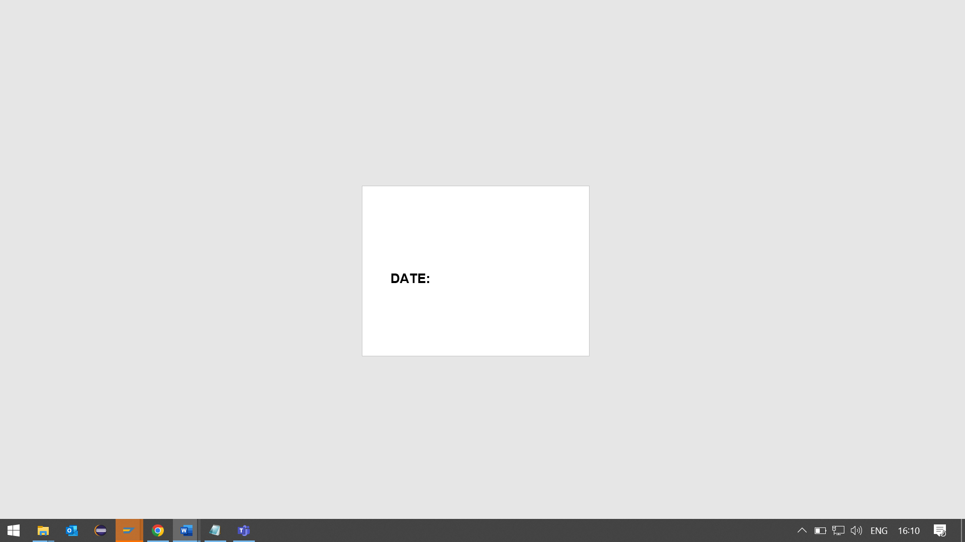

**ADDRESS WINDOW TO DISPLAY**

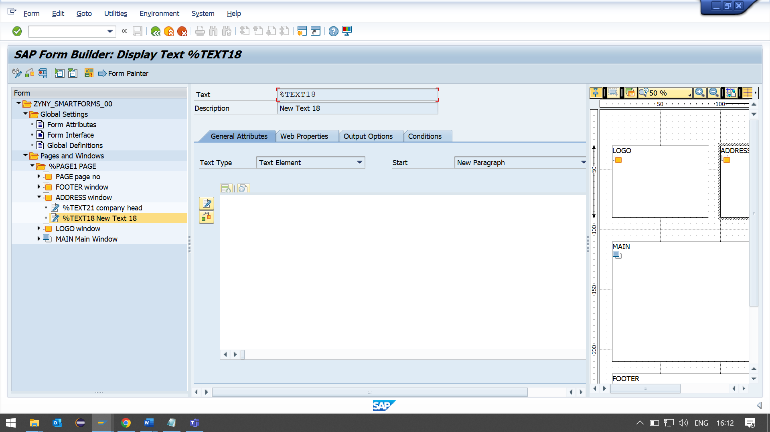

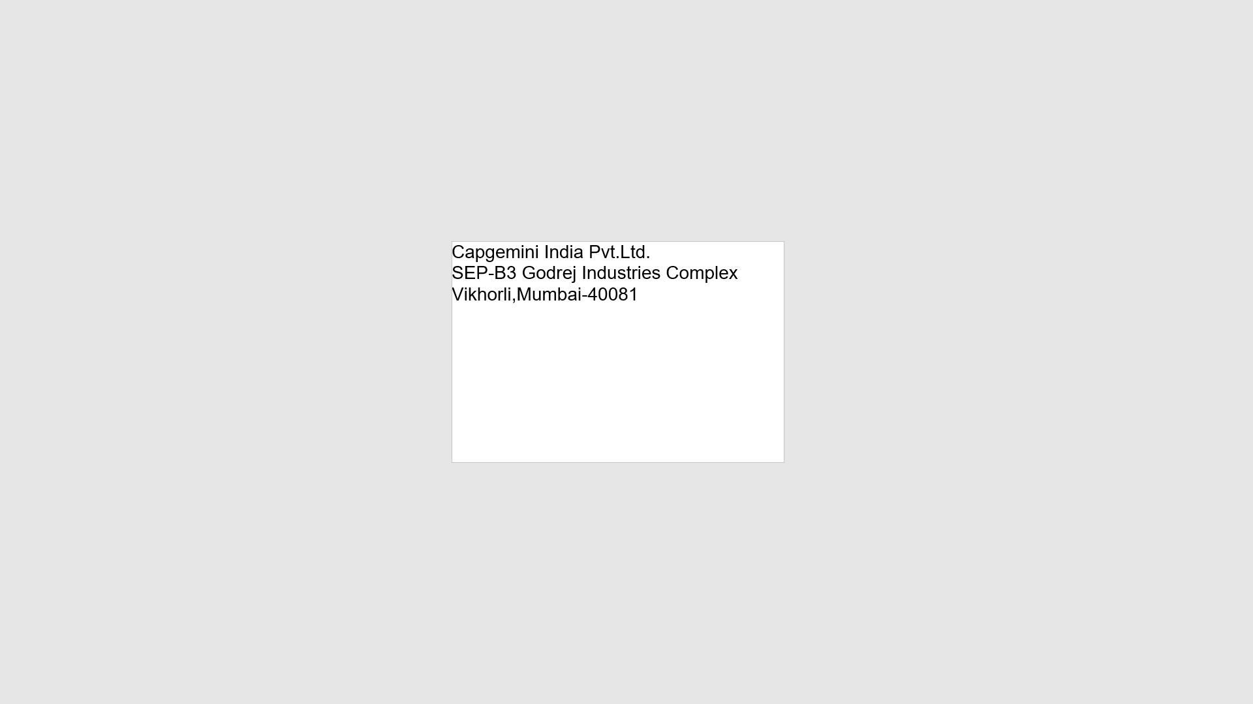

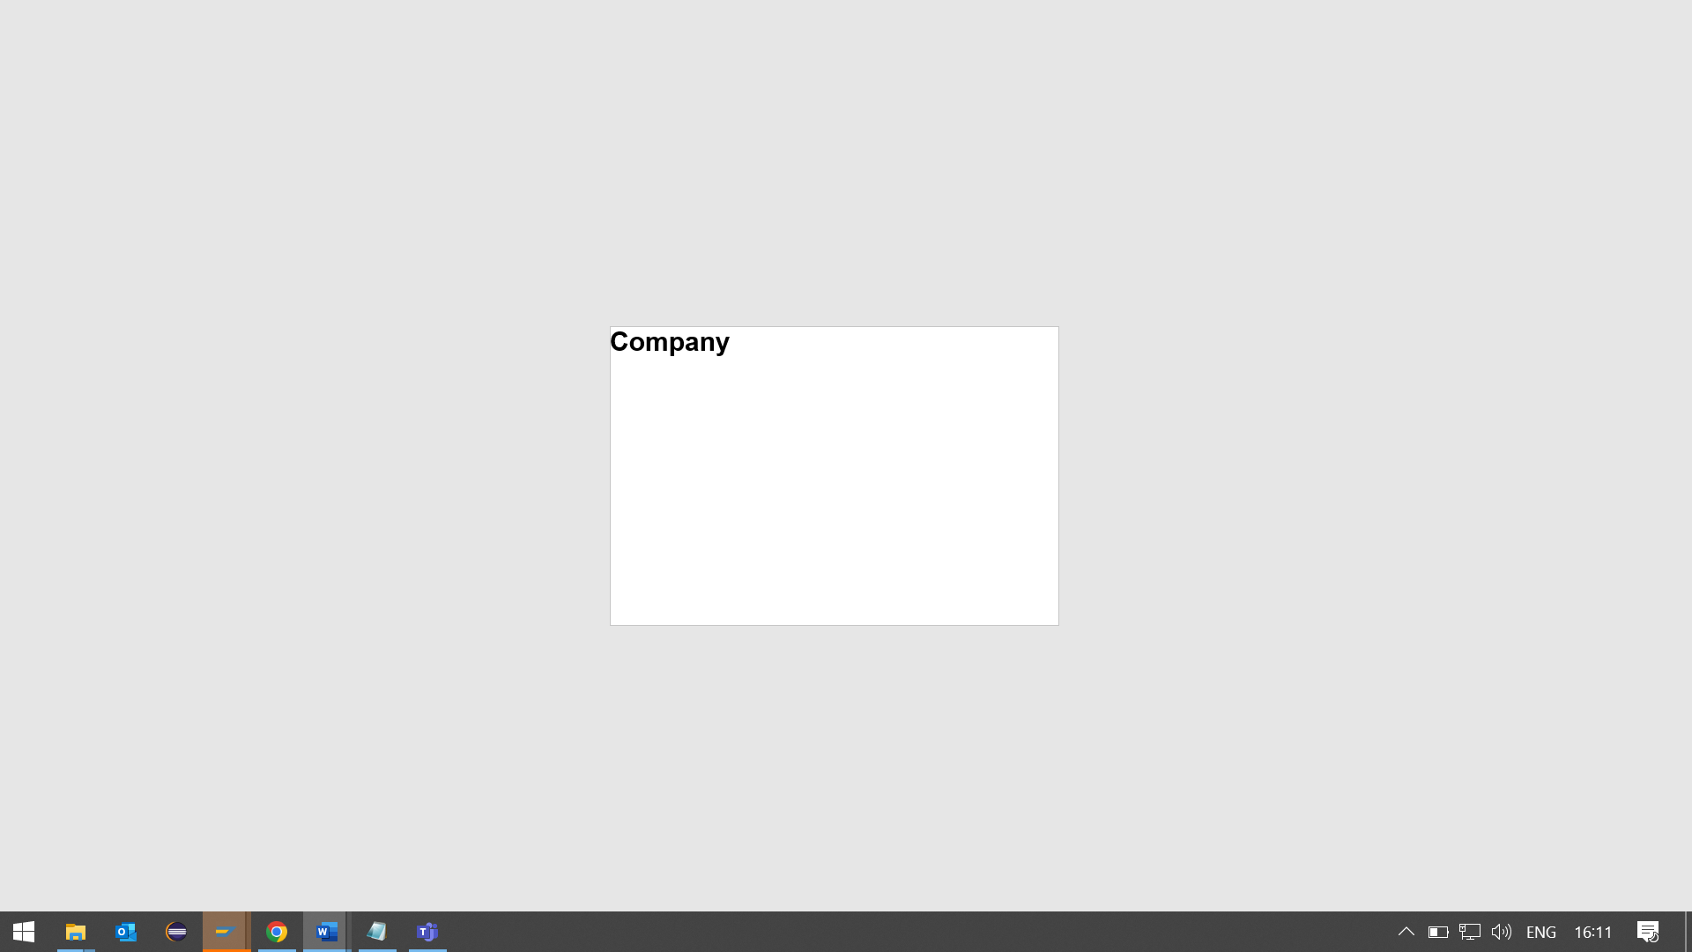

**FOOTER BLOCK**

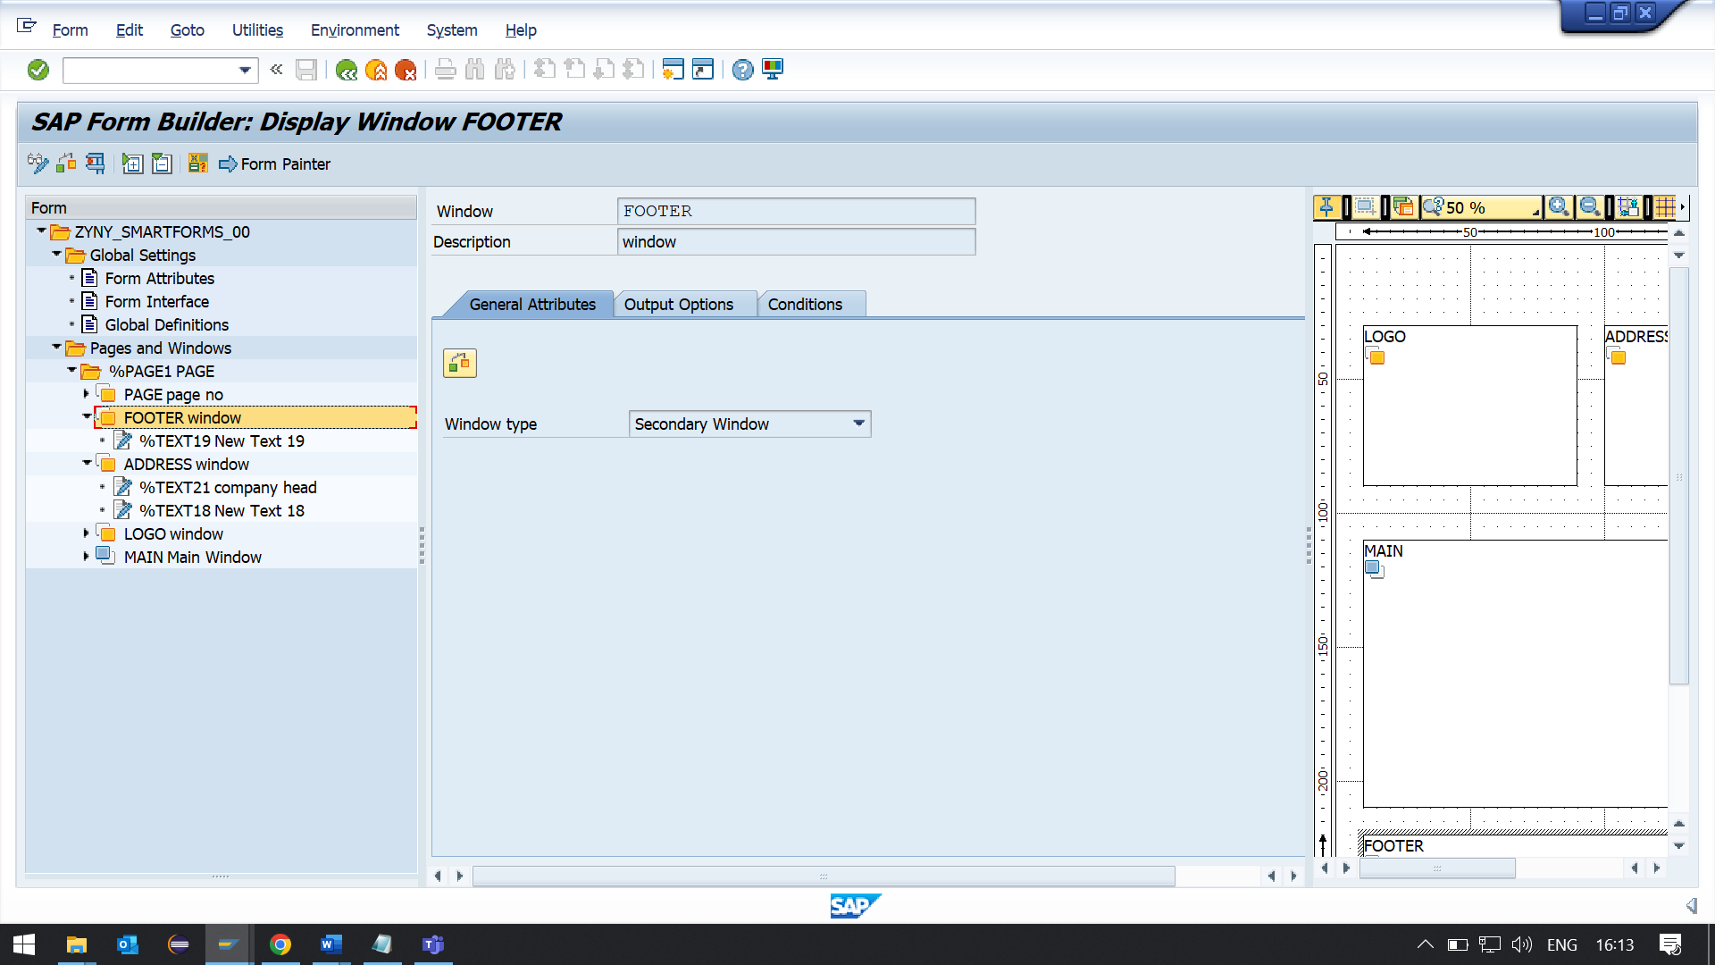

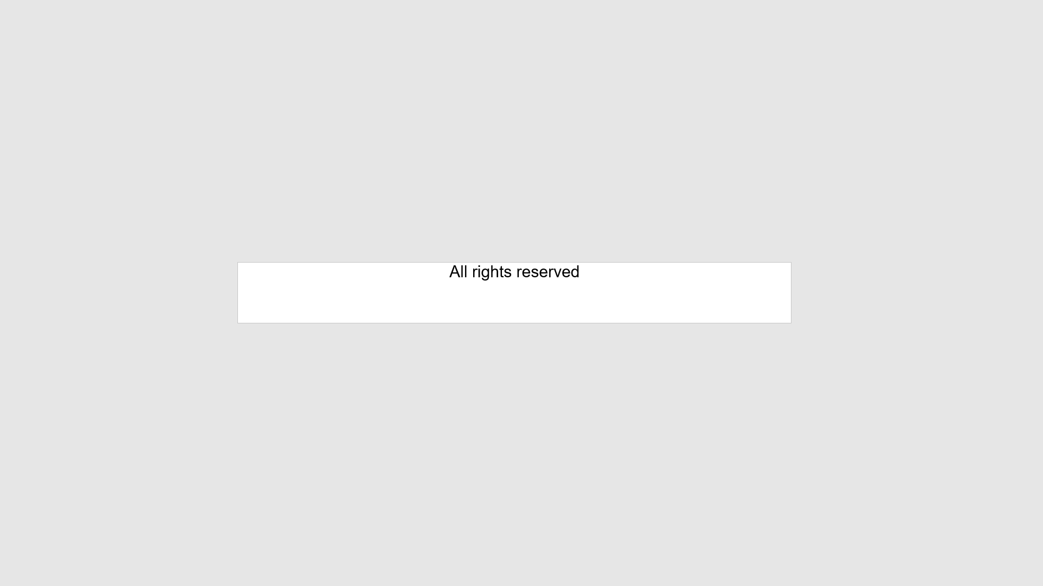

**PAGE BLOCK**

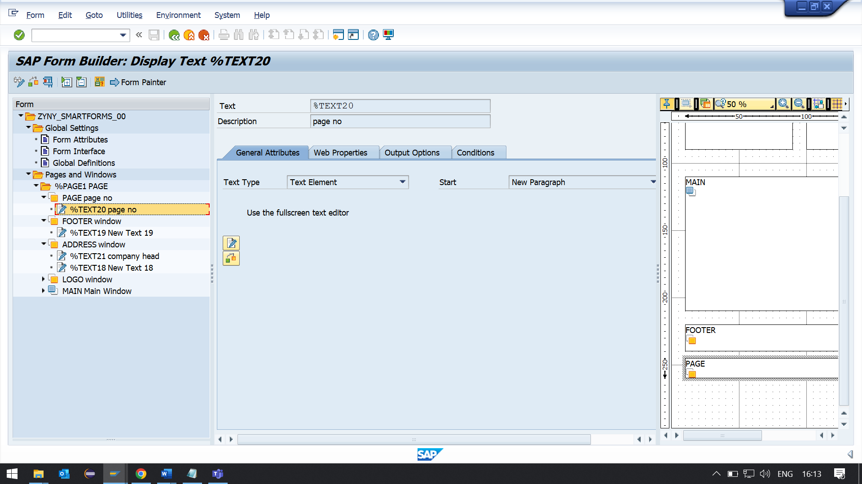

**MAIN WINDOW CODE PROGRAM LINE**

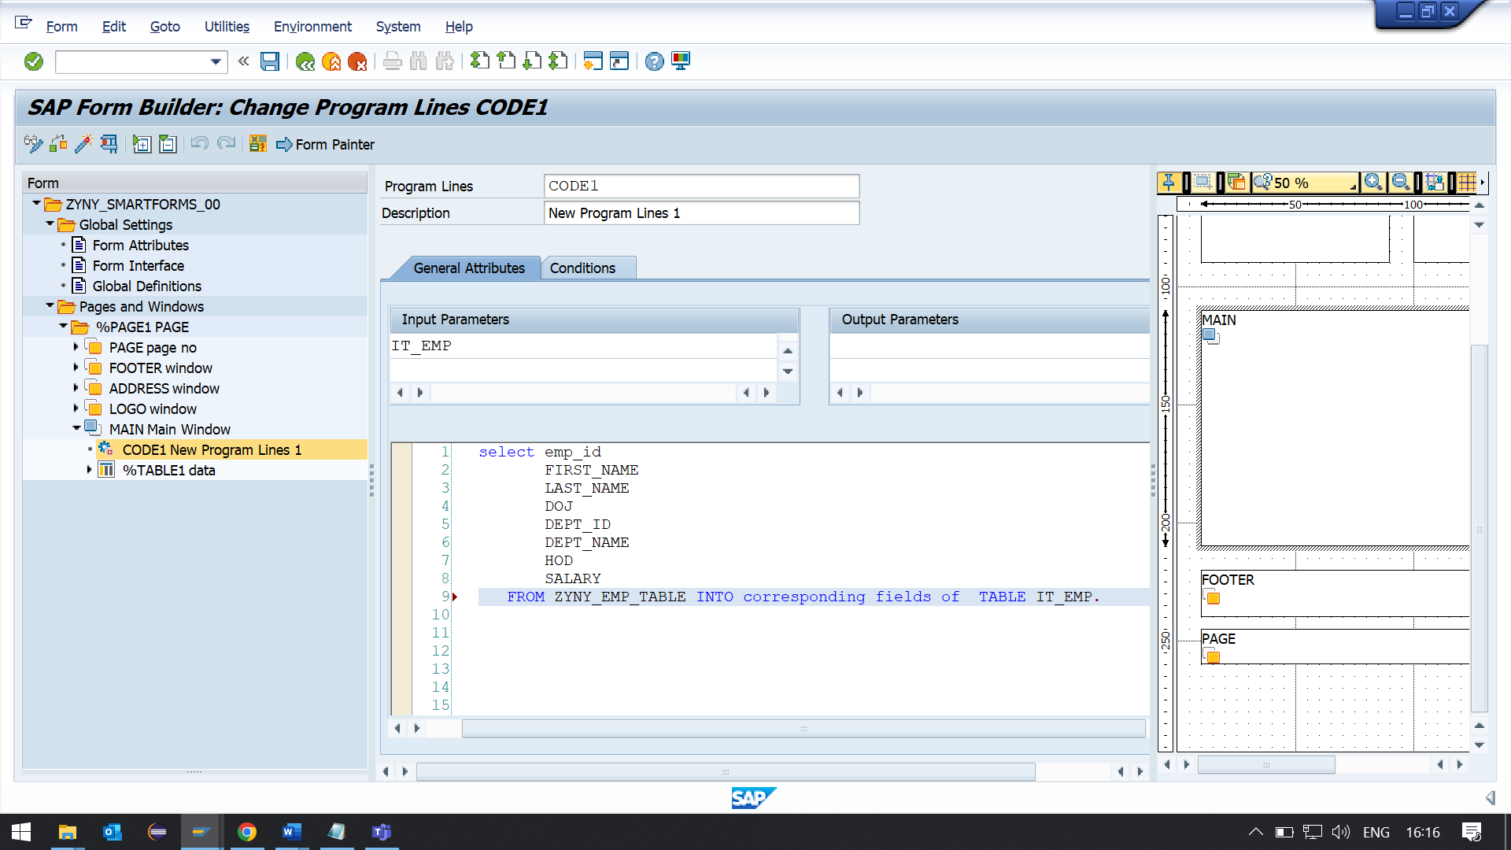

**TABLE TO DISPLAY DATA**

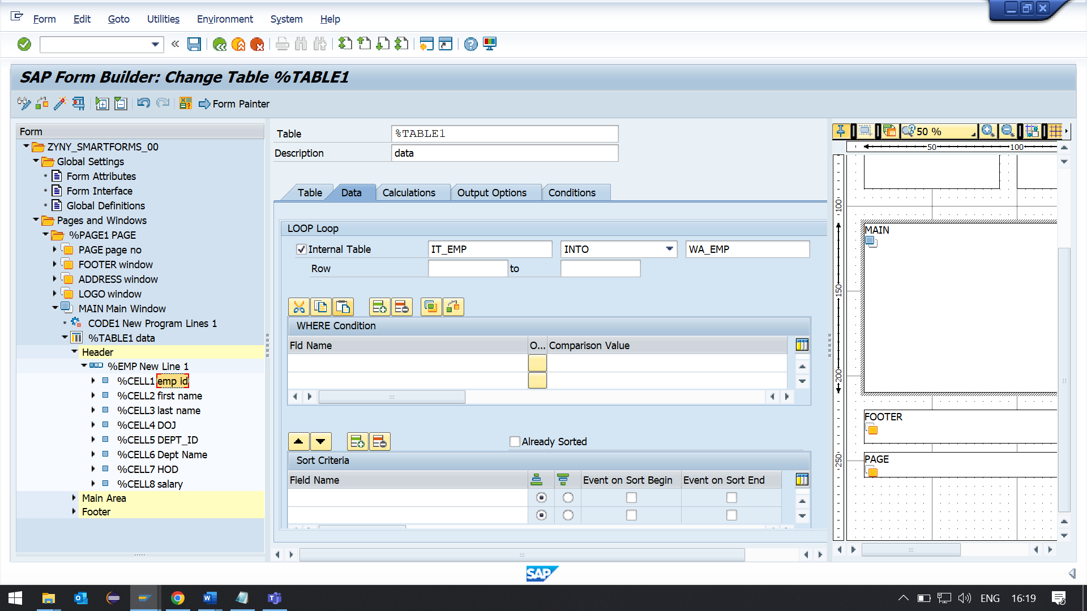

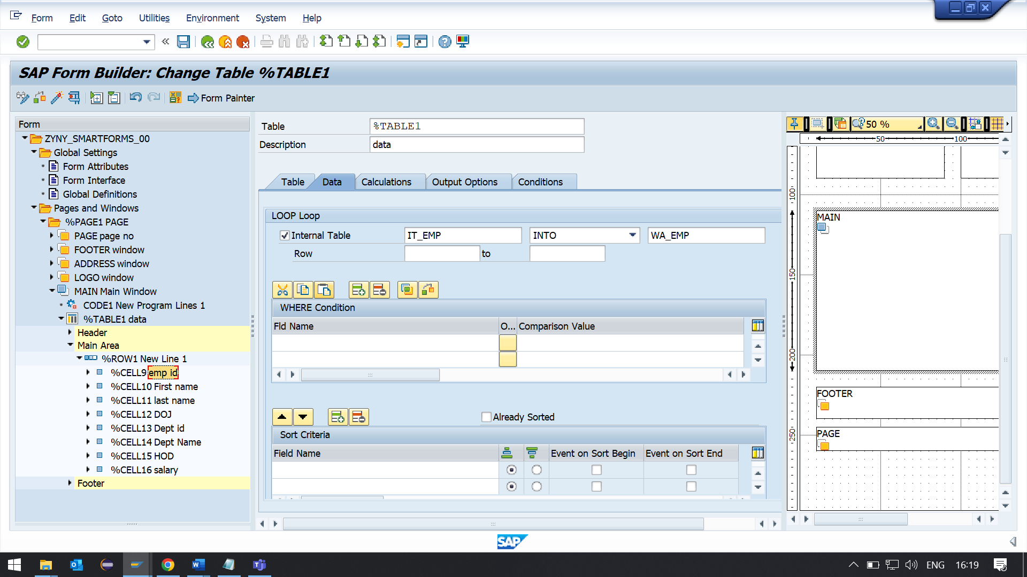

**PAGE**

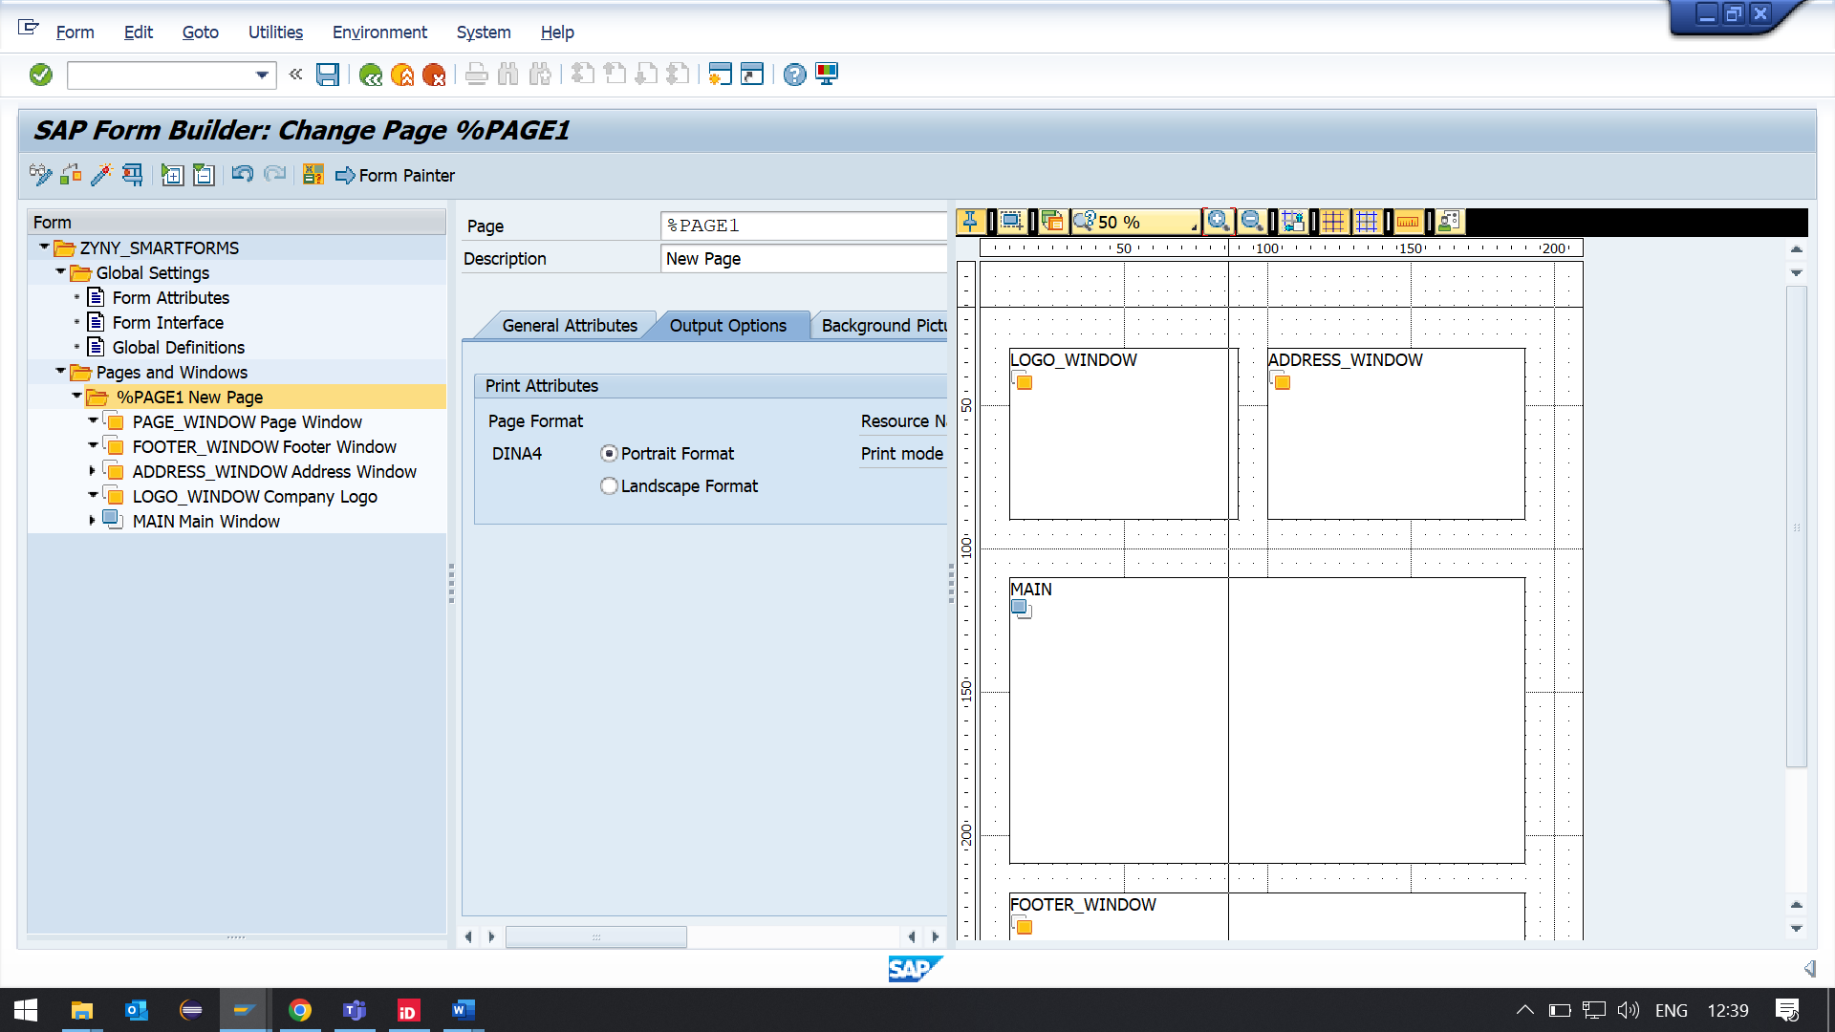

**OUTPUT**

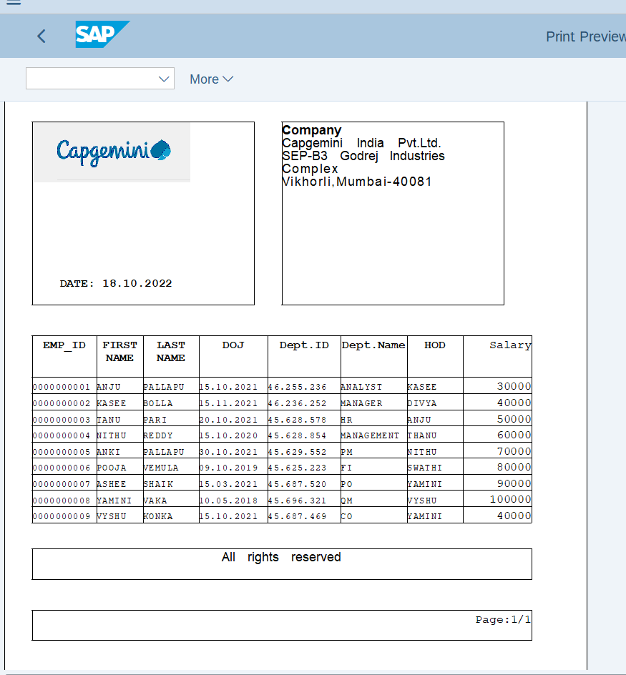

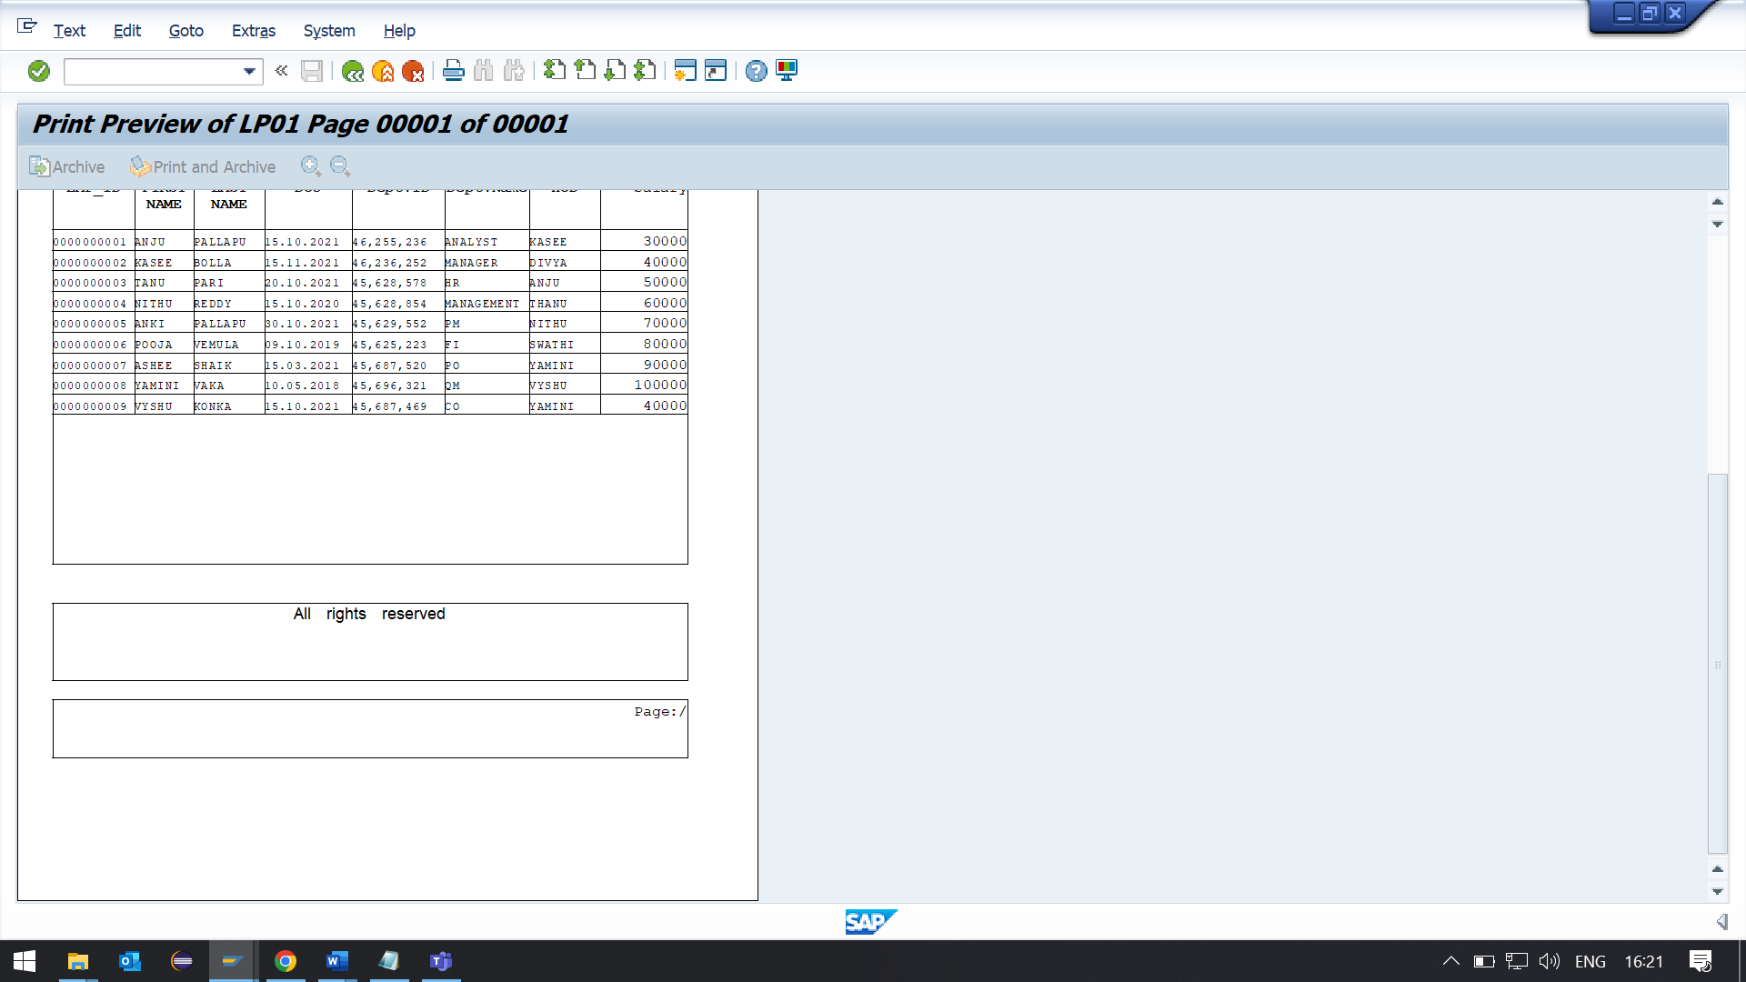

**REPORT**

TABLES:ZYNY_EMP_TABLE.  
Data : fm_name TYPE rs38l_fnam.  
  
  
START-OF-SELECTION.  
PERFORM generate_smartform.  
  
  
FORM generate_smartform .  
CALL FUNCTION 'SSF_FUNCTION_MODULE_NAME'  
  EXPORTING  
    formname                 = 'ZYNY_SMARTFORM_00'  
  
 IMPORTING  
   FM_NAME                  = fm_name  
 EXCEPTIONS  
   NO_FORM                  = 1  
   NO_FUNCTION_MODULE       = 2  
   OTHERS                   = 3  
          .  
IF sy-subrc <> 0.  
* Implement suitable error handling here  
ENDIF.  
  
  
CALL FUNCTION fm_name  
* EXPORTING  
*   ARCHIVE_INDEX              =  
*   ARCHIVE_INDEX_TAB          =  
*   ARCHIVE_PARAMETERS         =  
*   CONTROL_PARAMETERS         =  
*   MAIL_APPL_OBJ              =  
*   MAIL_RECIPIENT             =  
*   MAIL_SENDER                =  
*   OUTPUT_OPTIONS             =  
*   USER_SETTINGS              = 'X'  
* IMPORTING  
*   DOCUMENT_OUTPUT_INFO       =  
*   JOB_OUTPUT_INFO            =  
*   JOB_OUTPUT_OPTIONS         =  
 EXCEPTIONS  
   FORMATTING_ERROR           = 1  
   INTERNAL_ERROR             = 2  
   SEND_ERROR                 = 3  
   USER_CANCELED              = 4  
   OTHERS                     = 5  
          .  
IF sy-subrc <> 0.  
* Implement suitable error handling here  
ENDIF.  
  
  
  
  
ENDFORM.